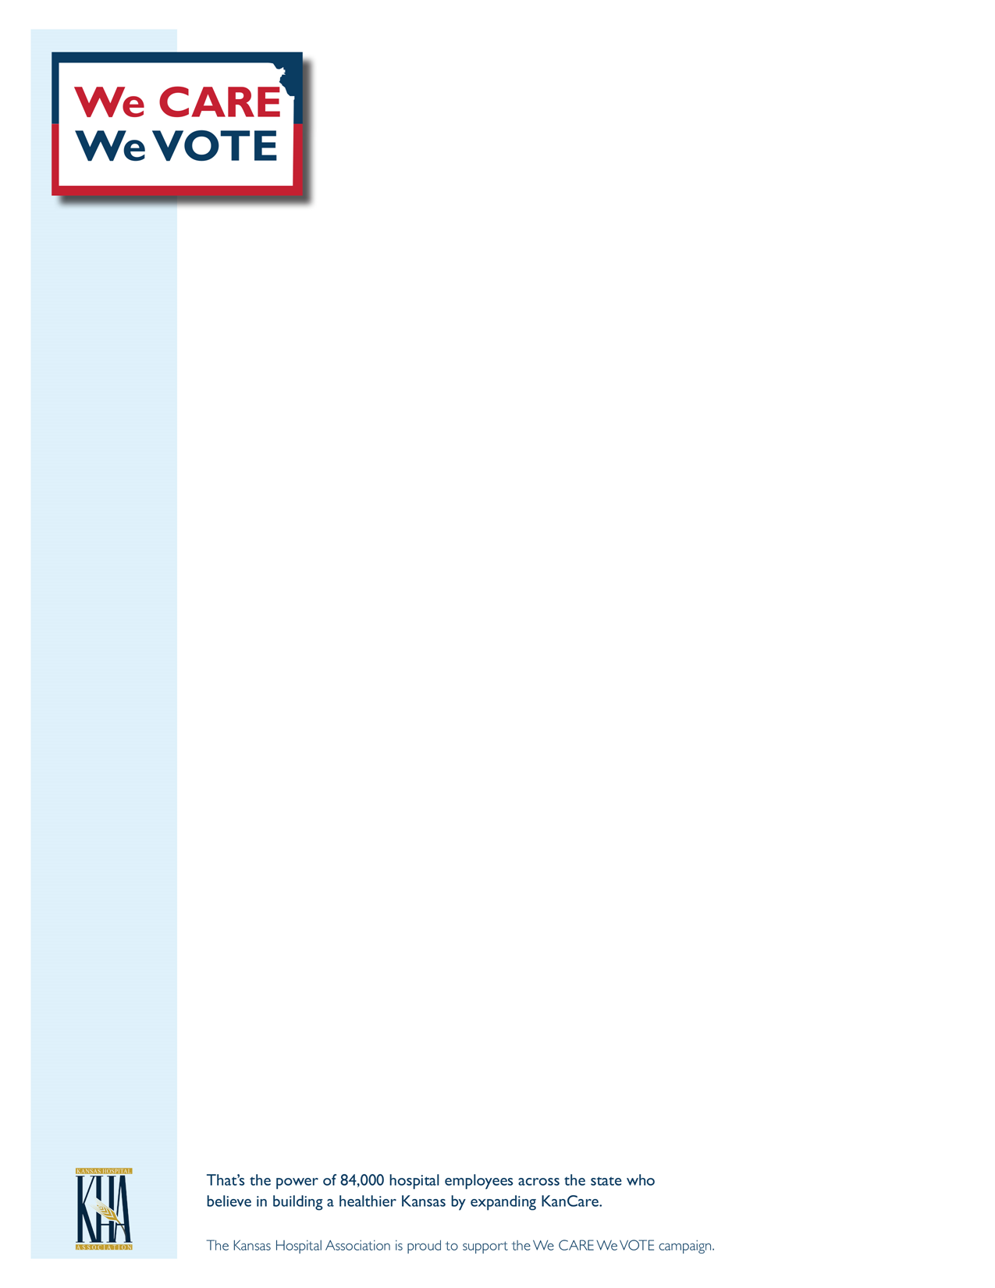

**Closing the Coverage Gap**

**How You Can Help Create Healthier Communities across Kansas**

You probably know someone - or have taken care of someone - who falls in the health insurance "coverage gap." These are hardworking people, many of whom work two or more part-time jobs with no health benefits. They are in the coverage gap because they earn too much to qualify for KanCare, but not enough to afford private health insurance.

The time has come to elect state leaders who want to make health care accessible for all Kansans. Strong leaders understand the importance of investing in Kansas communities and hospitals by passing legislation that strengthens our economy while protecting access to health care for all.

Expanding KanCare, for instance, would make health care coverage affordable for 150,000 hardworking Kansans. It would reduce the financial burden of uncompensated care for hospitals, and it would bring a net financial gain to our state that would result in more jobs and increased spending for economic gains.

We CARE We VOTE: Electing leaders who share our values of creating healthier Kansas communities is one important way to get involved. Before you head to the polls on November 8 for the general election, research the candidates on the ballot. Know where they stand on issues that affect the health of our community and the financial health of our hospital. Your vote matters. As a hospital employee in Kansas, you belong to a group that is more than 84,000 people strong. Together, we can make a difference.